1. Which of the following is *NOT* true about homeostasis?
2. It depends on the ability to sense changes to physiological condition.
3. It is accomplished by negative feedback.
4. It entails maintenance of constant physiological condition.
5. It requires energy.
6. Which of the following probably *NOT* an ectotherm?
7. A freshwater fish
8. A turtle
9. A small bird
10. A butterfly
11. All of the above are ectotherms.
12. As the temperature falls from 20C to 10C, it is likely that the metabolic rate of an endotherms goes _____, and the metabolic rate of an ectotherm goes ______.
13. Up, up
14. Up, down
15. down, up
16. Down, down
17. Falls, falls
18. Which of the following is *NOT* among the organic constituents of foods?
19. Fiber
20. Vitamins
21. Minerals
22. Lipids
23. All of the above are among the organic constituents of foods.
24. Which of the following is true about cellulose digestion?
25. It produces simple sugar molecules.
26. It is a trait present in some adult humans but not others.
27. It requires an enzyme that is synthesized by herbivores but not carnivores.
28. It is accomplished by mechanisms separate from those for digesting fiber.
29. In cows, it is accomplished in the large intestine.

6. Compared to a pound of table sugar, a pound of fiber contains ________ energy content and _______ digestibility.

a. lower; lower

b. lower; similar

c. higher; lower

d. similar; lower

e. similar; similar

1. Imagine that you usually put 15 g of sugar (about a tablespoon) in your coffee, and you drink two cups per day. As a diet strategy, you decide to start drinking your coffee sugar-free. Assuming that everything else stays the same, how long would it take for this diet change to accumulate enough reduced calorie intake to lose one pound of fat?
2. 1 week
3. 2 weeks
4. 4weeks
5. 10 weeks
6. 20 weeks
7. The major vessel connected to the mammalian right ventricle carries blood that is ________ in oxygen _________ the heart.
8. enriched; toward
9. enriched; away from
10. depleted; away from
11. depleted; toward

8. Which of the following is true of G proteins in hormone signaling?

a. The G protein activates the hormone receptor

b. The G protein is a second messenger.

c. The G protein is an enzyme that catalyzes synthesis of cAMP

d. The G protein is activated when the hormone receptor binds to a hormone.

e. The G protein turns off the hormone signal pathway.

9. Which of the following is true about regulation of urine volume?

1. ADH is released by the kidneys.
2. ADH reduces filtration.
3. ADH stimulates insertion of aquaporins in cell membranes.
4. ADH inhibits osmosis.

10. Some marine birds, like gulls and albatrosses, have glands in their heads (modified from glands that produce tears) that produce a salt solution with a concentration of about 1000 mosM/l.

Compared to the blood, that solution is ___________ concentrated, and producing the solution is likely to involve ____________.

1. More, passive transport
2. Equally, passive transport
3. More, active transport
4. Equally, active transport
5. Less, passive transport

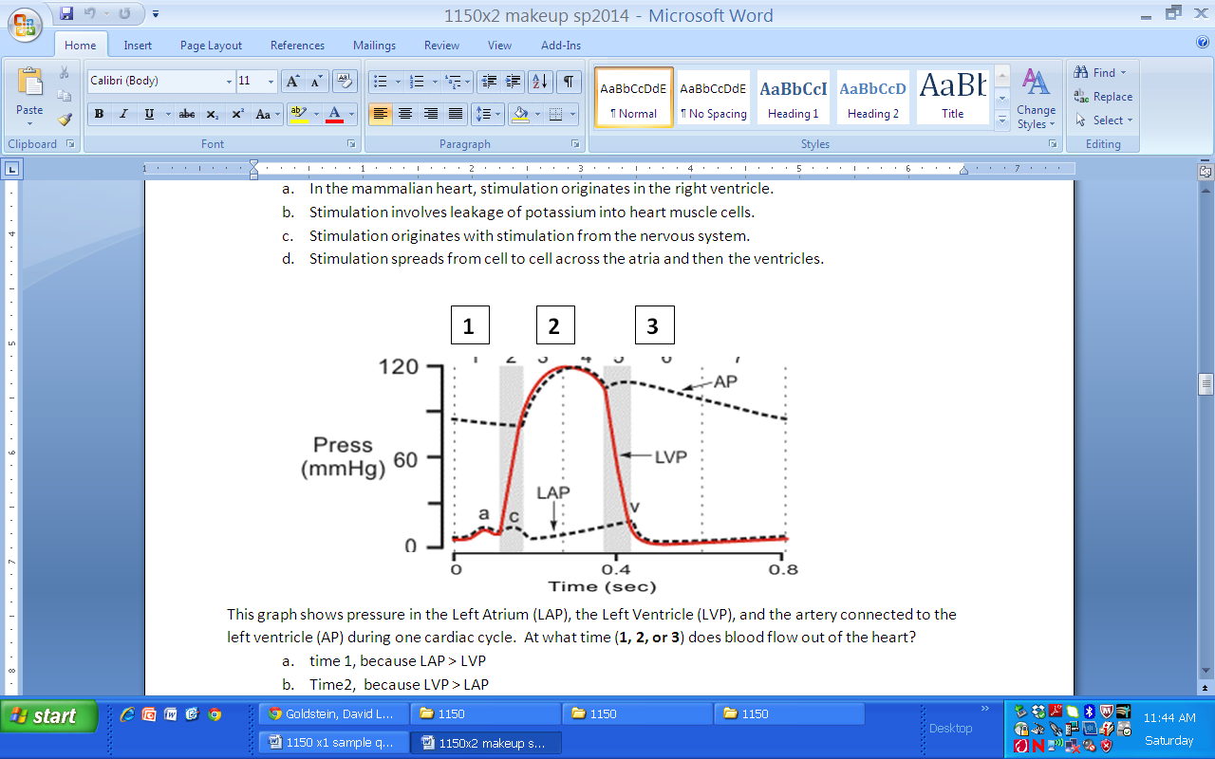

11. This graph shows pressure in the Left Atrium (LAP), the Left Ventricle (LVP), and the artery connected to the left ventricle (AP) during one cardiac cycle. At what time (**1, 2, or 3**) does blood flow out of the heart?

1. time 1, because LAP > LVP
2. Time2, because LVP > LAP
3. Time 2, because LVP > AP
4. Time 3, because AP > LAP
5. Time 3, because AP > LVP

Indicate whether the following relate to

1. Steroid hormones
2. Peptide hormones
3. Both peptide and steroid hormones
4. Neither peptide nor steroid hormones

12. ______ use second messenger

13. ______contribute to negative feedback pathways

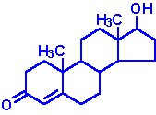

14. ______

Answers:

1. C Homeostasis is not specifically a constant or exact status
2. C birds and mammals are the only that are uniformly endothermic not ectothermic
3. B
4. C
5. A
6. D both 1 lb of sugar and 1 lb of fiber are the same but fiber is a lower digestion
7. C Sugar has an energy contain of 4 cal per gram and 40 g per day. 22hund. Gram sin a pound
8. C Right is low in O and left is high in O
9. D
10. C
11. C Our blood is concentrated at 300 and the sea water is a concentration of 1000.

Also, Active transport is the moving from more diluted concentration to a more concentrated solution

1. C The graph is called the wiggeries diagram. Shows three parts. A graph of 1 heartbeat. Left atrium gen less pressure than the atrium. For blood to flow out of heart. It must travel from left ventricle to the aorta through a valve called the aortic valve or the semi lunar valve. Only when pressure in the LV must be greater than the pressure in the Aorta. Allowing the valve to open when the valve closes this is when the pressure in the LV is less than the aorta. Stopping backwards flow.
2. Uses second messenger: Only pepdides = B
3. Contributes to neg feedback loop: All do = C
4. A just be familer with the design of the steriiods and we don’t have to know the differences between the different kinds. Same with the Peptide hormones. We don’t have to tell the difference between the different structuees. Just know whats a peptide and a setiod.

Notes from Review:

Filtration: is bulk fluid pressure gen in many ways

Osmosis: force drives by concentration driving across semipro able membrane.

Difference between peptide and Steroids. Peptide based on Amino Acids and can’t cross the cell membrane, and the receptor makes the travel across. Where are steroids can travel across the membrane.

Animal Form and Function

Hormones:

Metabolic cascade: each step of activation and deactivation of receptor responses with the cells acting in low concentration within the blood.

Relationship between Enzyme and the second messenger:

Key is the hormone never enters the cell and sets the receptor to send the g protein to the enzyme to activate the second messenger through the ATP.

Differences in the different signals are mainly with the distance they travel

Posterior are cells connected to the brain and the Anterior are separate from the brain.

Posterior only has 2 targets to interact with and the Anterior has several throughout the body.

Osmoregulation:

Just know the Lymphatic system is an open system and nothing to in-depth

ADH activating a second messenger cAMP from an Enzyme

Hormone(ADH) flows in the blood. The receptor is activated and then the reaction can happen anywhere in the cell.

ADH purpose is to allow water to travel through the cell membrane to the urine. To reduce urine vol. We lead to an increase of Water dilution and allow the urine to be more concentrated and excreted and make sure no water leaves.

Urine concentration mechanism: blood has concentration of 300 moles/l so the water is the same at the start, too complicated to explain everything…...

The more you pee the lower your blood pressure.

It’s a mechanism to have urine more concentration that the blood concentration. For mammals.

Digestion and Nutrition:

Macro molecules need to be converted into small molecules to be digested by the gut. Can be done in ma y ways such as the stomach acid. Or enzymatic action.

Mainly focused on the principles and used examples. So have a good look at the principles and can see how they are acting in the examples given if you can.

Circulatory System:

Known the basics and what the left verses the right side of the heart does but don’t go into deep specifics.